Plan:

OVERVIEW:

Core concept

Genre

Target audience

Unique selling point

BACKGROUND

Counter Strike

Call of Duty Warzone Gulag

Superhot

SUMMARY:

Basic game story (more like the objective here than the story)

Player characters

Visuals

Level design

Controls (game feel – fast, slow?)

Reason for chosen engine

TWO ELEMENTS FROM PROTOTYPE:

Fps movement and shooting

Network functionality

VIDEO DEMO

START OF WRITING:

Main header: Overview of “no excuses.”

“no excuses.” is the fairest multiplayer game ever made. It’s a fast-paced online 1v1 FPS game where the only focus is shooting the other player in the head. Players are placed into an arena where the obstacles in front of them are randomized every time, giving you no advantage in learning layouts. The whole environment is a pristine white, so you can focus on nothing but shooting the other player.

Other online First-Person Shooter games are full of distractions. The enemies in “Counter- strike” blend right into the background, meanwhile the enemies in “Valorant” are surrounded by bright and distracting colours. It’s an easy excuse to make as to why you missed that shot. Furthermore, both games named previously are Team-based shooters, giving you something else to blame as to why you’re losing. What if you had a game where you couldn’t make any such excuses? Where the only reason you lose is because you’re worse at the game. You have no excuses. Competition at its core.

Players are placed at either end of an arena and have to find and kill each other. Who ever kills the other person first earns a point. To keep the game fast paced, the game works in a Best of 5 format. First to three points wins.

Sub header: Genre

The genre of this game is an Online Multiplayer First-Person Shooter. The majority of games in this genre are team-based, in a 5v5 or 6v6 format, or sometimes a free-for-all “deathmatch” format. This game is instead a 1v1 game, featuring only you and your enemy.

Sub Header: Target Audience

I would give this game an age rating of 18. The plan is to include the player characters exploding and their blood splattering across the white walls like paint on a canvas. This should make it more satisfying and momentous for when a player kills the opponent, even if it does up the player rating. The game may seem boring to players below 18 anyway, since they might not be interested in such a simple format which strips away the stimulation of bright colours that typically appeals to them.

Sub Header: Unique selling point

The unique selling point of my game is that it’s a fair environment for people to face off against each other in 1v1 aim duels. People who play multiplayer FPS games love trying to prove they’re better than one another. You’ll often hear the phrase “1v1 me” in team multiplayer games such as “Valorant” despite the game not at all being designed around that. This can be extended to gamers in general, who talk about “settling it in smash” meaning 1v1ing each other in a game of Super Smash Bros. I want my game to be the fairest and most equal environment for a 1v1 FPS duel, hence the white background and coloured players.

Main Header: Background

These are some games that helped to inspire the making of this game.

Sub Header: Game 1: Quake

Quake is a First Person Shooter released in 1996 by id Software. The game had both an expansive singleplayer campaign, and multiplayer servers for people to face off against eachother in deathmatches. The movement of quake was always very fast and fluid, and the player could build up a lot of momentum. One of the most popular multiplayer modes was “Instagib”, where every player had a railgun, and everyone can die in just one hit. This made for a chaotic mode of people trying to dodge and weave lasers while waiting for their railgun to recharge.

The elements of Quake that will be implemented into this game are the fast paced and fluid movement, and the instant killing of enemy players found in the Instagib mode.

Sub Header: Game 2: Call of Duty Warzone

Call of Duty Warzone is a Online Multiplayer FPS Battle Royale game. The main part of COD Warzone is it’s large world battle royale, where players fight to be the last one standing. The way they differentiated themselves from other battle royales though is by having the Gulag. The Gulag is a 1v1 arena you and another player are placed into when you die in the battle royale. The arena is small and rectangular, with several obstacles placed between you and the other player. Your job is to kill the other player in order to be resurrected and rejoin the battle royale world. When the mode released in 2020, players were only allowed a pistol or revolver of some kind. Nowadays though they have full rifles and shotguns, which gives the player too much power in these fights. In addition, there is skill expression in learning the maps/layouts of the Gulag, of which there are several.

The elements that will be taken from Call of Duty Warzone’s Gulag for this game are the enclosed 1v1 fights, and the feeling of powerlessness with in your weapons – having only a pistol rather than a rifle.

Sub Header: Game 3: SUPERHOT

SUPERHOT is a Single-player FPS game where time only moves when you move. The game was developed by a small team as a Game Jam game in 2013, before being turned into a full game in 2016. It has levels where the player is placed into a perfectly white environment and is instructed to kill bright red enemies shooting at them. According to SUPERHOT’s Art Director Marcin Surma, this art style was only chosen because it was easy to make and allowed the developers to focus on the gameplay, since this was a Game Jam game and they didn’t have much time. After their decision to turn it into a full game though, they kept the art style as it made it immediately clear what the player needed to focus on in the game, removing all distractions. This art style is a big inspiration to this project, as it aligns with the goal of removing all distractions from the player so they can focus on landing their shot.

The elements of SUPERHOT that will be implemented into this art style is it’s ultra-minimalistic art style, and it’s focus on highlighting enemies in a primary colour.

Main Header: Summary

Sub Header: Game Story/Objective

Since this is a multiplayer game about shooting opponents, there isn’t really a clear story to be told since it’s not at all grounded in reality. The focus is entirely on the gameplay. Some multiplayer games have “lore” as to why the characters are here and fighting, like Valorant, which every time they have a new multiplayer season, has a cinematic video to go with it giving context as to why there’s a new character or a new map. For this game, it’s so abstract as it is that it’s not necessary to give context via story.

Instead, we can talk about the objective of the game. To win, the player has to kill the opponent 3 times before the opponent kills them. The overall objective though is to be best at the game. Players will be assigned a score based on how many games they win or lose, similar to a rank in other online games. This score will be used in matchmaking to make sure players play against opponents of similar skill levels. When playing against a friend, the player will be able to view their current record of wins and losses against the enemy, for example 2-6.

Sub Header: Player Character

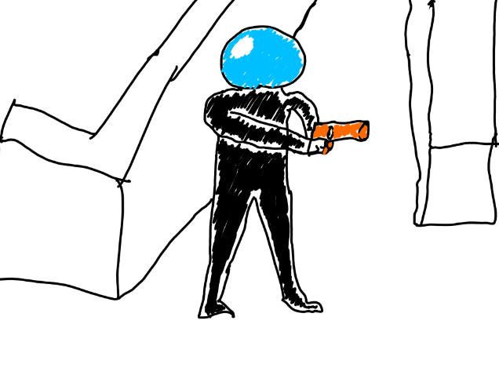The player characters, like the world, will be designed to be minimalistic. They should stand out easily from the background while still being visually distinct. Since the head is the only part of the character that can be shot, the head should be a different colour from the body to make that clearer. My design makes the character black with a bright blue head. I chose blue for several reasons. The first is that while red is more distinct, the game SUPERHOT (see background) already used red for their enemies and I don’t want to copy their aesthetic entirely. The next reason is that blue is a colour seen by all types of colour-blindness. Having Deuteranopia of Protanopia types of colour-blindness means that the colour red looks more like a strange yellow colour. All three types of colour-blindness can see blue though. It may look a little different between the types, but it’s visually distinct regardless. Therefore, not even being colourblind is an excuse in this game.

I increased the size of the head as well, since it’s the only part of the character that matters and therefore should be more prominent. It does make the game easier since being larger makes it easier to hit, but the game is already difficult since the head is typically very small.

In this drawing , I made the gun orange. This was purely to make it clear that it isn’t part of the character. I may change the colour of the gun later on, this part isn’t decided yet.

Sub Header: Aesthetic

This game is designed to be as minimalist as possible. The idea of the game is to give the player as little distractions as possible, so they can focus on aiming and killing the opponent. Therefore, the game will have completely white backgrounds and obstacles. This way, the opposing player should be the only focus on the screen when playing. The game will still be detailed, in that there will be a variety of interesting obstacles for the player to play around.

Lots of other multiplayer games either try to make the game as realistic looking as possible, or as colourful and vibrant as possible. By instead leaning into this minimalist aesthetic, this game will stand out of the crowd as something truly different.

Sub Header: Level Design

For level design I have decide to create a circular arena, where the obstacles are randomized each time. My concept art showed placing players on a random angle around the arena, but since it is circular, and players will be